MongoDB Lab Assignments -Day 1

MongoDB Exercise in mongo shell

Connect to a running mongo instance, use a database named mongo_practice.

Document all your queries in a javascript file to use as a reference.

Insert Documents

Insert the following documents into a movies collection.

title : Fight Club

writer : Chuck Palahniuko

year : 1999

actors : [

Brad Pitt

Edward Norton

]

title : Pulp Fiction

writer : Quentin Tarantino

year : 1994

actors : [

John Travolta

Uma Thurman

]

title : Inglorious Basterds

writer : Quentin Tarantino

year : 2009

actors : [

Brad Pitt

Diane Kruger

Eli Roth

]

title : The Hobbit: An Unexpected Journey

writer : J.R.R. Tolkein

year : 2012

franchise : The Hobbit

title : The Hobbit: The Desolation of Smaug

writer : J.R.R. Tolkein
year : 2013

franchise : The Hobbit

title : The Hobbit: The Battle of the Five Armies

writer : J.R.R. Tolkein

year : 2012

franchise : The Hobbit

synopsis : Bilbo and Company are forced to engage in a war against an array of combatants and keep the Lonely Mountain from falling into the hands of a rising darkness.

title : Pee Wee Herman's Big Adventure

title : Avatar

Reference

https://www.tutorialspoint.com/mongodb/mongodb_insert_document.htm

Query / Find Documents

query the movies collection to

- get all documents
db.movies.find()
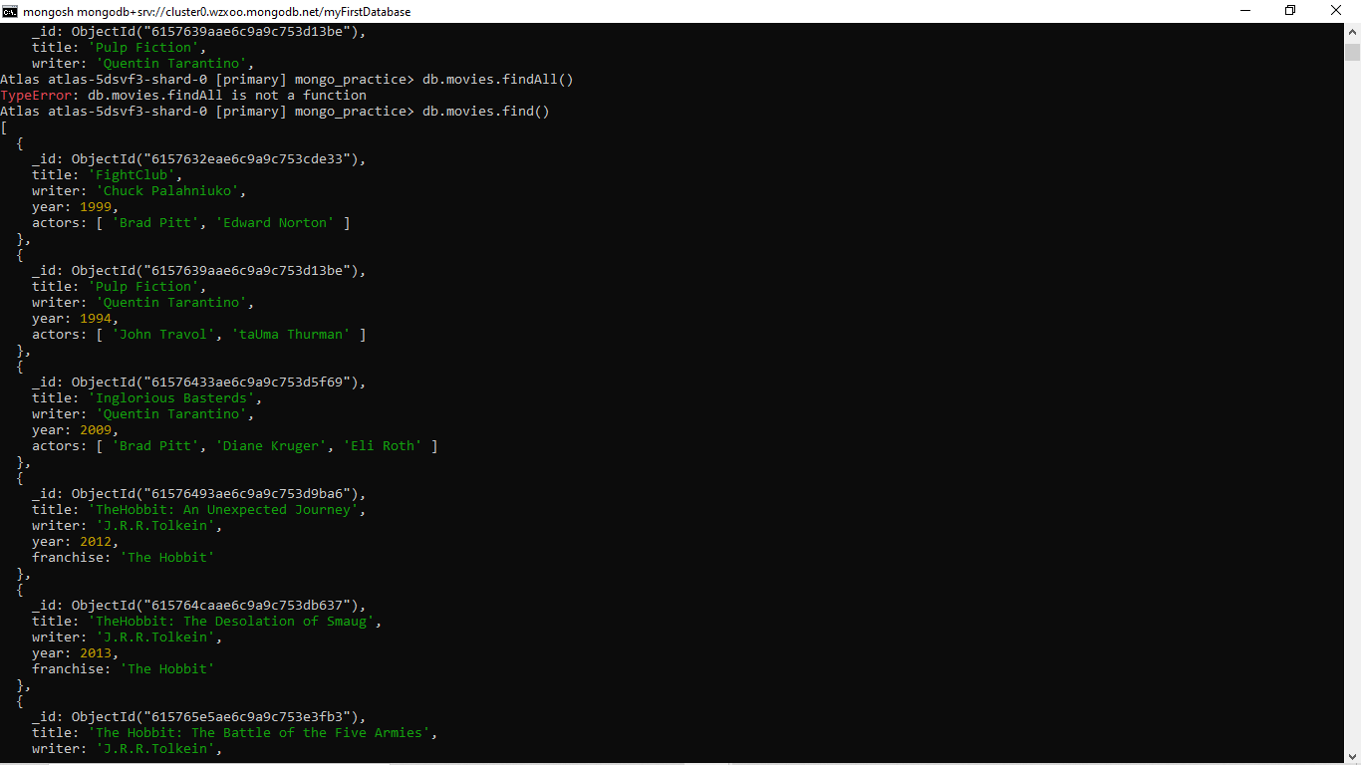
- get all documents with writer set to "Quentin Tarantino"
db.movies.find({writer:"Quentin Tarantino"})
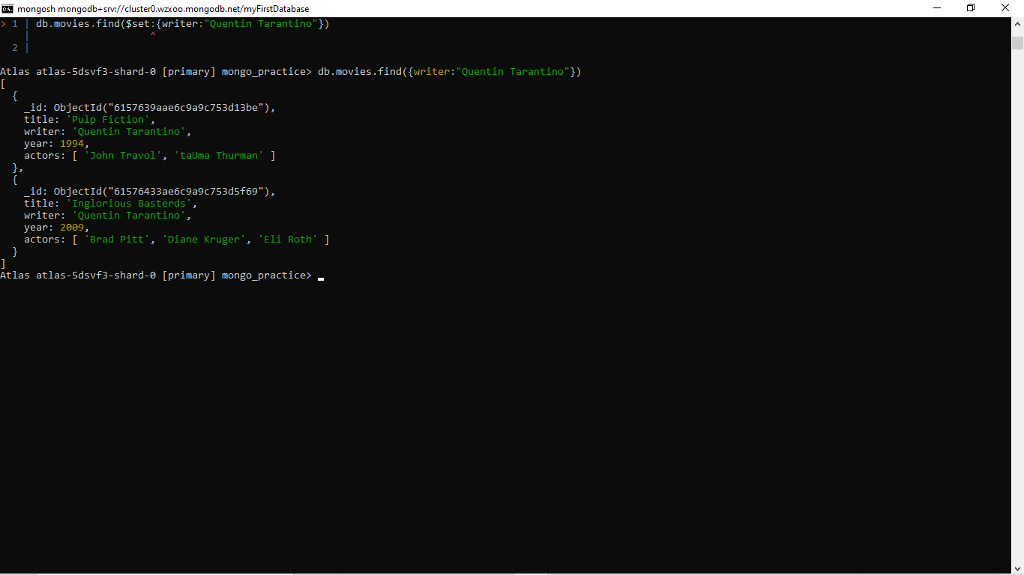

- get all documents where actors include "Brad Pitt"
db.movies.find({actors:"Brad Pitt"})
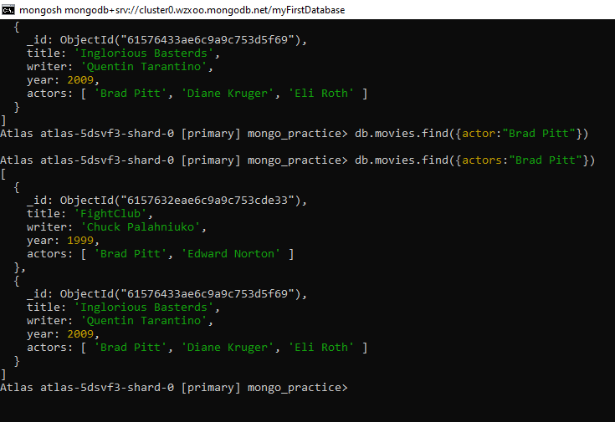
- get all documents with franchise set to "The Hobbit"
db.movies.find({franchise:"The Hobbit"})
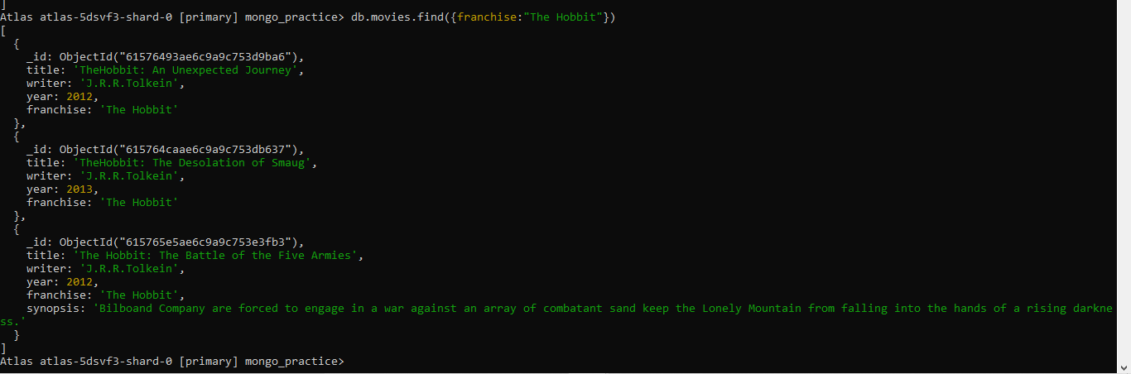

- get all movies released in the 90s
db.movies.aggregate([{$match:{year:{$lt:2000}}}])
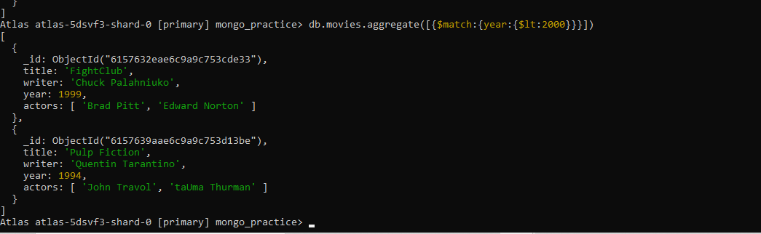

- get all movies released before the year 2000 or after 2010
db.movies.find({$or:[{year:{$lt:2000}},{year:{$gt:2010}}]})
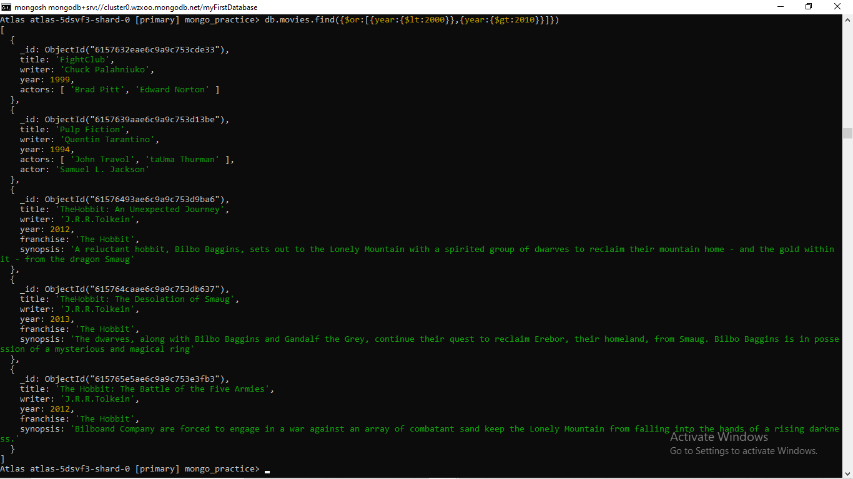

Update Documents

- add a synopsis to "The Hobbit: An Unexpected Journey" : "A reluctant hobbit, Bilbo Baggins, sets out to the Lonely Mountain with a spirited group of dwarves to reclaim their mountain home - and the gold within it - from the dragon Smaug."
db.movies.updateOne(
... {"_id":ObjectId("61576493ae6c9a9c753d9ba6")},
... {$set:{"synopsis":"A reluctant hobbit, Bilbo Baggins, sets out to the Lonely Mountain with a spirited group of dwarves to reclaim their mountain home - and the gold within it - from the dragon Smaug"}},
... {"upsert":true})

- add a synopsis to "The Hobbit: The Desolation of Smaug" : "The dwarves, along with Bilbo Baggins and Gandalf the Grey, continue their quest to reclaim Erebor, their homeland, from Smaug. Bilbo Baggins is in possession of a mysterious and magical ring."

db.movies.updateOne(
... {"_id":ObjectId("615764caae6c9a9c753db637")},
... {$set:{"synopsis":"The dwarves, along with Bilbo Baggins and Gandalf the Grey, continue their quest to reclaim Erebor, their homeland, from Smaug. Bilbo Baggins is in possession of a mysterious and magical ring"}},
... {"upsert":true}
- add an actor named "Samuel L. Jackson" to the movie "Pulp Fiction"
db.movies.updateOne( { "_id":ObjectId("6157639aae6c9a9c753d13be") }, { $set: { "actor":"Samuel L. Jackson" } }, { "upsert": true })

Reference:
https://www.tutorialspoint.com/mongodb/mongodb_update_document.htm

Text Search

- find all movies that have a synopsis that contains the word "Bilbo"
db.movies.find({"synopsis":{$regex:".*Bilbo.*"}})

- find all movies that have a synopsis that contains the word "Gandalf"
db.movies.find({"synopsis":{$regex:".*Gandalf.*"}})

- find all movies that have a synopsis that contains the word "Bilbo" and not the word "Gandalf"
db.movies.find({"$nor":[{"synopsis":{$regex:".*Gandalf.*"}}]})

- find all movies that have a synopsis that contains the word "dwarves" or "hobbit"
db.movies.find({$or:[{synopsis:{$regex:”dwarves”}},{synopsis:{$regex:”hobbit”}}]})

- find all movies that have a synopsis that contains the word "gold" and "dragon"
- db.movies.find({$and:[{synopsis:{$regex:”gold”}},{synopsis:{$regex:”dragon”}}]})

Reference: https://www.tutorialspoint.com/mongodb/mongodb_text_search.htm

Delete Documents

- delete the movie "Pee Wee Herman's Big Adventure"
db.movies.remove({'title':"Pee Wee Herman's Big Adventure"})

- delete the movie "Avatar"
db.movies.remove({'title':"Avtar"})

Reference:
https://www.tutorialspoint.com/mongodb/mongodb_delete_document.htm

Relationships

Insert the following documents into a users collection

[{username : GoodGuyGreg,

first_name : "Good Guy",

last_name : "Greg"
},

{username : “ScumbagSteve”,

full_name :””,
,
first : "Scumbag",

last : "Steve"}]

Insert the following documents into a posts collection

username : GoodGuyGreg

title : Passes out at party

body : Wakes up early and cleans house

username : GoodGuyGreg

title : Steals your identity

body : Raises your credit score

username : GoodGuyGreg

title : Reports a bug in your code

body : Sends you a Pull Request

username : ScumbagSteve

title : Borrows something

body : Sells it

username : ScumbagSteve

title : Borrows everything

body : The end

username : ScumbagSteve

title : Forks your repo on github

body : Sets to private

Insert the following documents into a comments collection

username : GoodGuyGreg

comment : Hope you got a good deal!

post : ObjectId ("615889176fb730a9f546dc4e")

where [post_obj_id] is the ObjectId of the posts document: "Borrows something"

username : GoodGuyGreg

comment : What's mine is yours!

post : ObjectId("615889576fb730a9f546fe56")
where [post_obj_id] is the ObjectId of the posts document: "Borrows everything"

username : GoodGuyGreg

comment : Don't violate the licensing agreement!

post : ObjectId("615889826fb730a9f5471517")

where [post_obj_id] is the ObjectId of the posts document: "Forks your repo on github

username : ScumbagSteve

comment : It still isn't clean

post : ObjectId("615888736fb730a9f5467f23")
where [post_obj_id] is the ObjectId of the posts document: "Passes out at party"

username : ScumbagSteve

comment : Denied your PR cause I found a hack

post : ObjectId("615888e26fb730a9f546c1ce")

where [post_obj_id] is the ObjectId of the posts document: "Reports a bug in your code"

Querying related collections

- find all users
db.users.find()
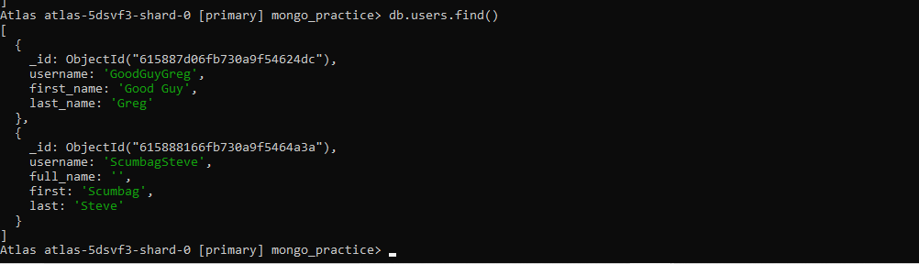

- find all posts
db.posts.find()
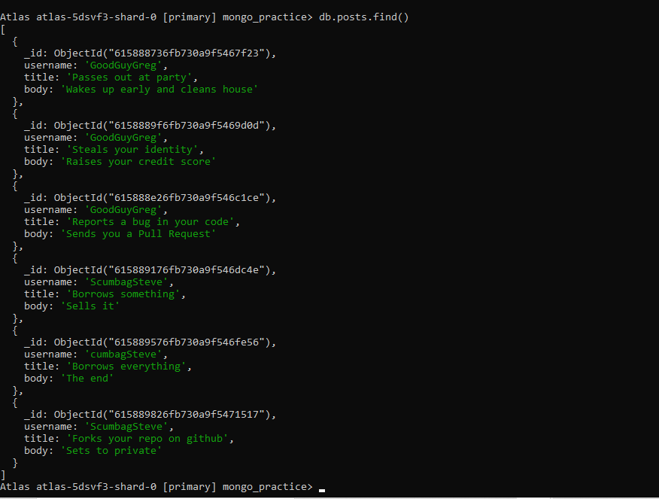

- find all posts that was authored by "GoodGuyGreg"
db.posts.find({"username":"GoodGuyGreg"})

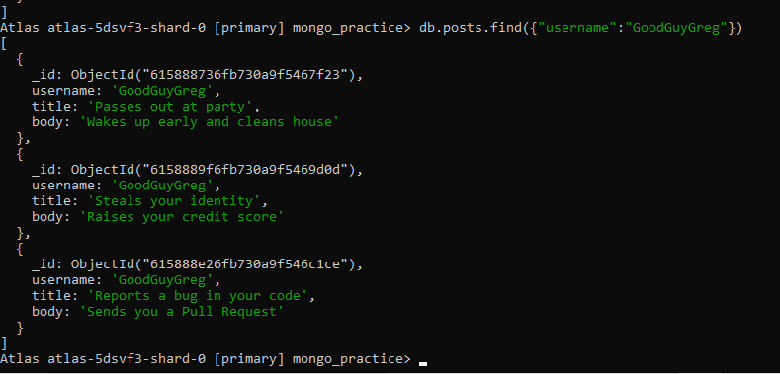

- find all posts that was authored by "ScumbagSteve"
db.posts.find({"username":"ScumbagSteve"})
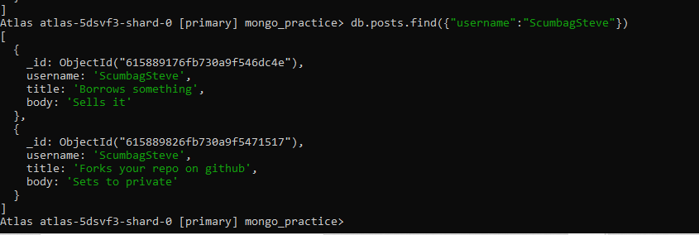

- find all comments
db.comments.find()
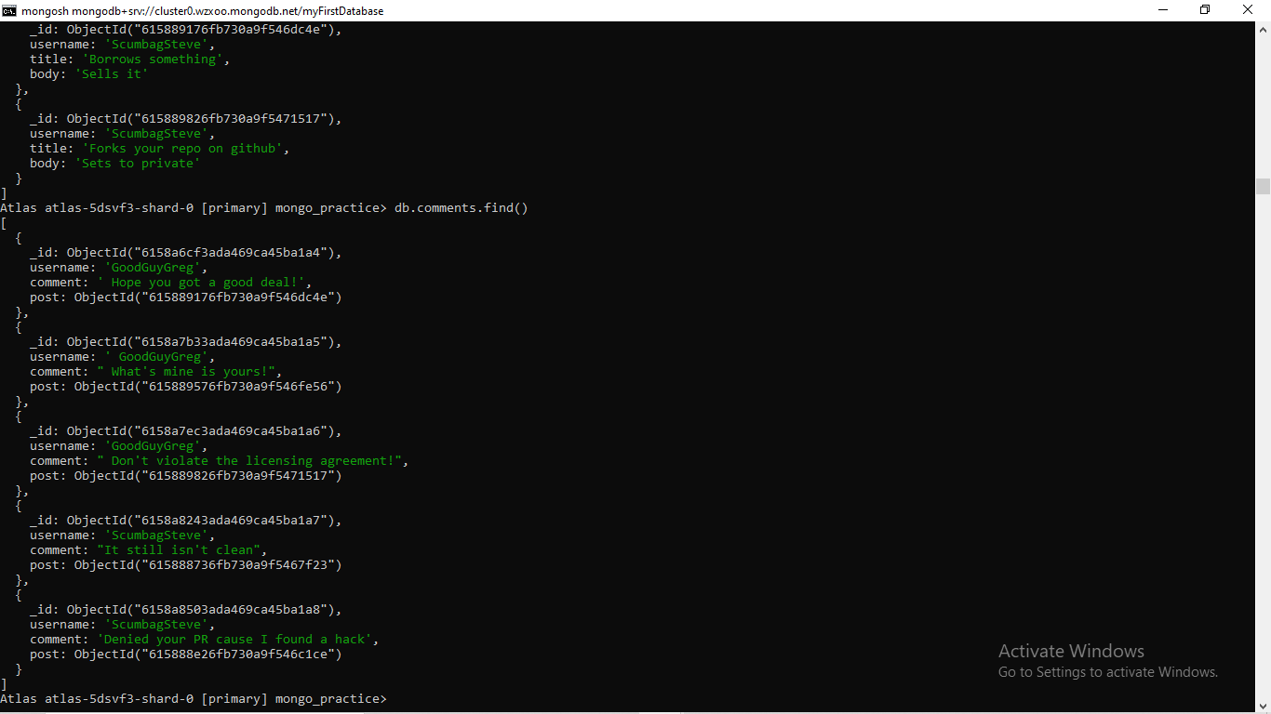

- find all comments that was authored by "GoodGuyGreg"
db.comments.find({"username":"GoodGuyGreg"})

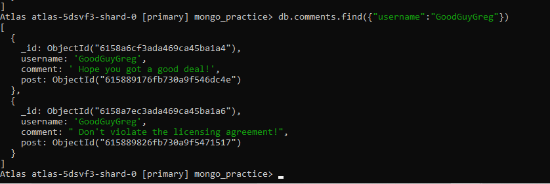
- find all comments that was authored by "ScumbagSteve"
db.comments.find({"username":"ScumbagSteve"})
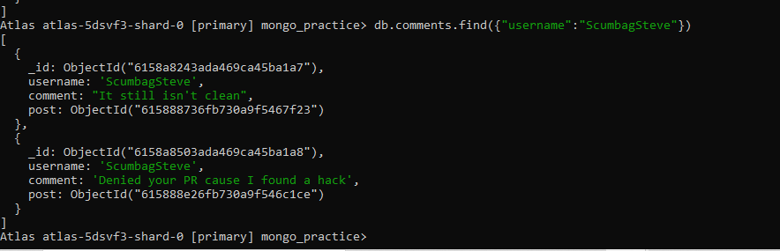

- find all comments belonging to the post "Reports a bug in your code"

References:

https://docs.mongodb.com/manual/reference/method/db.collection.find/

@@@@@@@@@@@@@@@@@@@@@@@@@@@@@@@@@@@@@@@

